**LAB MANUAL**



**ROLLNO:AV.SC.U4CSE24124**

**NAME: G . Balaji Ajay**

**SECTION: CSE-B**

**WEEK-1:**

**Aim:** How to install jdk and first program on

printing student details*.*

**Step-1:** Download JDK-21 from oracle website

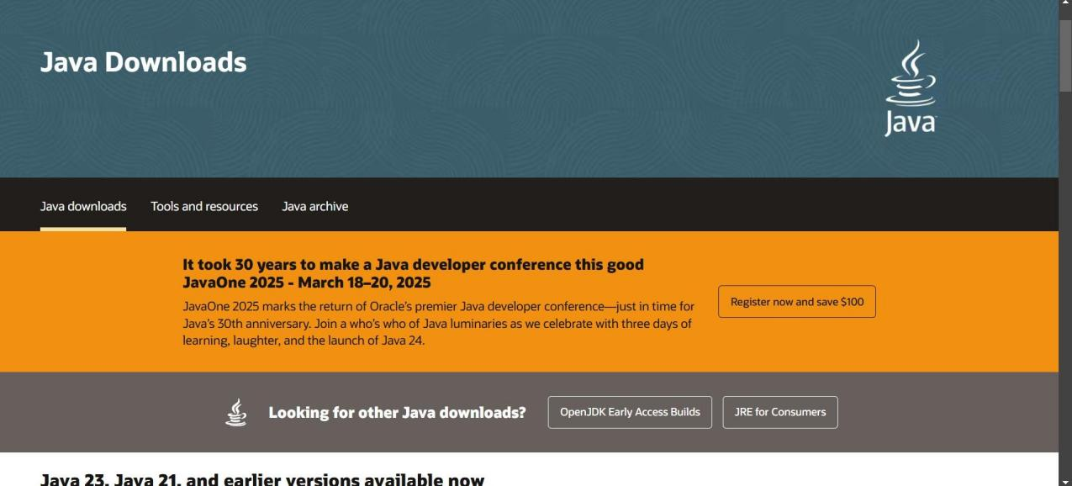

**Step-2:**Install the JDK-21 with accepting terms and

conditions according to the respective windows.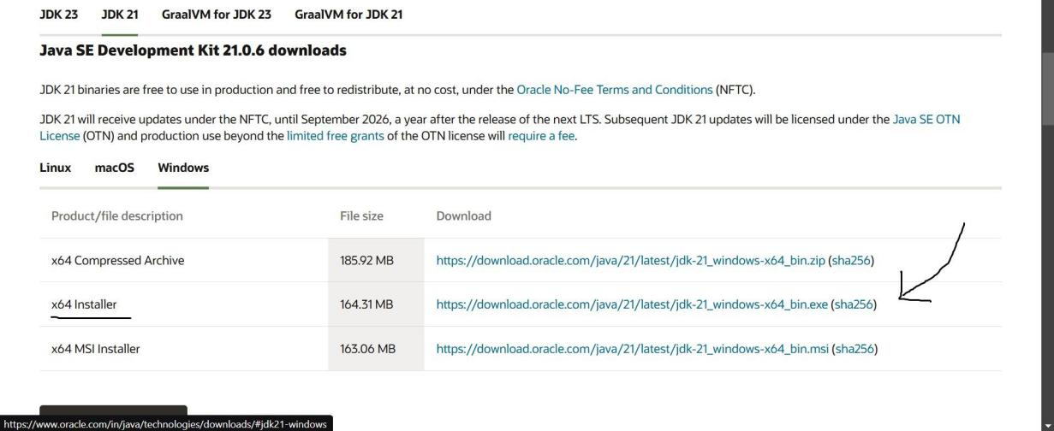

**Step-3**:Setting up environmental variables.

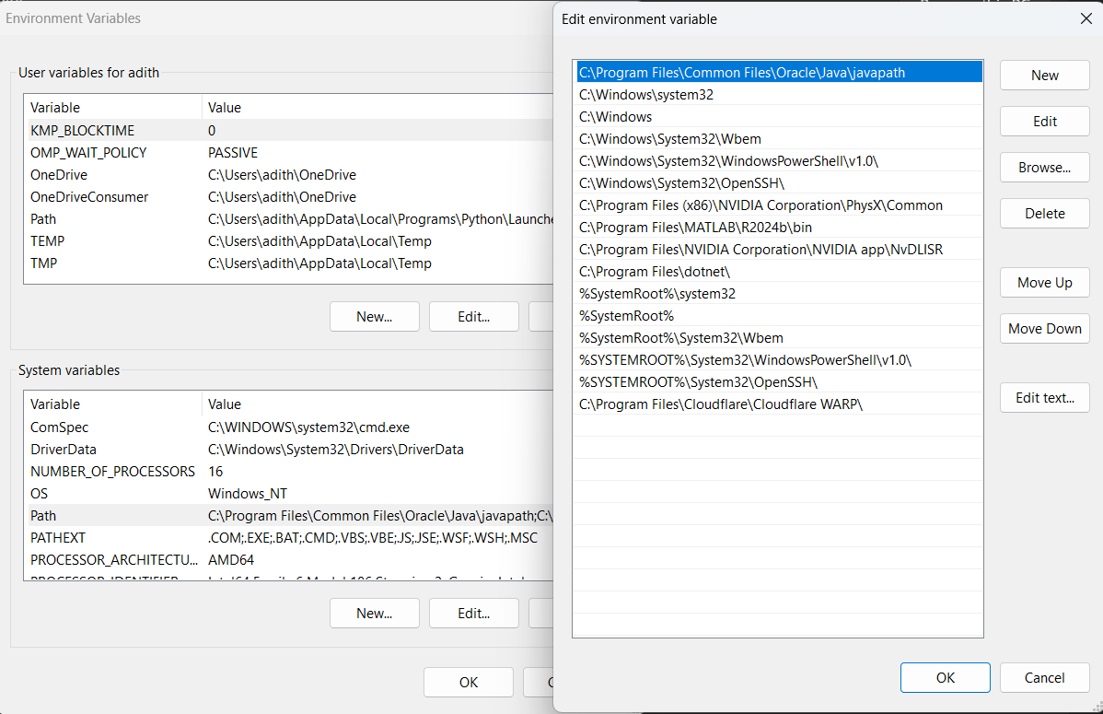

*Windows c -> C-drive -> program files ->Java -

>JDK-21->select bin

*Select and open environmental variable in search

bar-> either select system variables or user

variables-> select path-> click edit->New-> paste

the bin-> finish the setup(apply the changes).

~for verifying the installed version

Open cmd-> type java --version

~command propt

Javac filename.java ->compiling.

Java filename.java ->displaying

**PROGRAM-1(Rectified):**

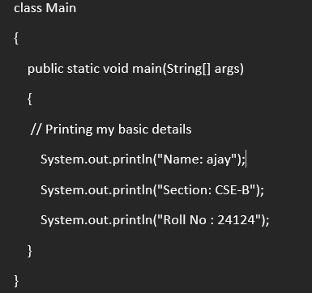

**Output:**

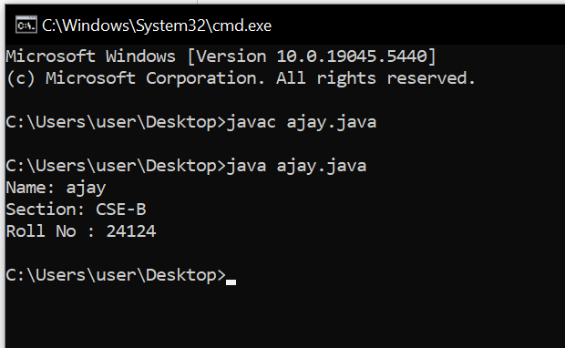

**WEEK-2:**

**PROGRAM-1:**

**Aim:**Write a java program for SI

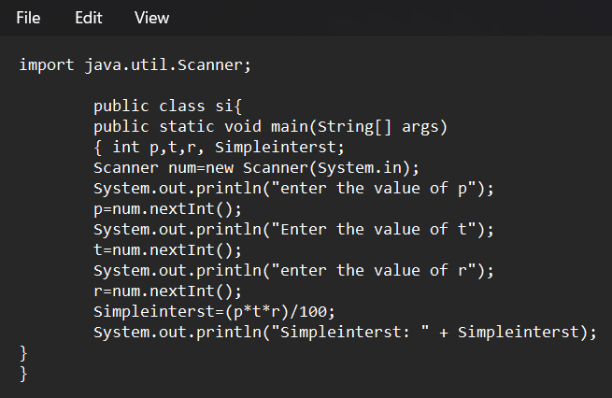

**Output:**

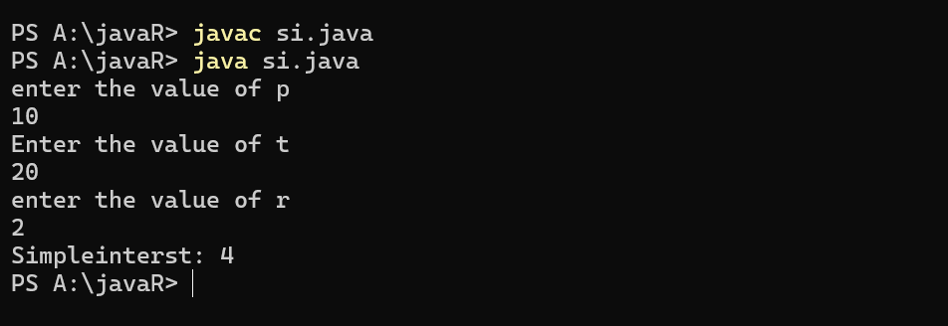

**ERROR TABLE*:***

|  |  |
| --- | --- |
| **Code Error** | **Code rectification** |
| 1.Giving space between next and Double.  2.Not giving parenthesis after closing the input. | 1.Should not give space between next and Double.  2.We must put parenthesis after closing the input. |

**PROGRAM-2:**

**Aim:**Write a program in java for area of

rectangle.

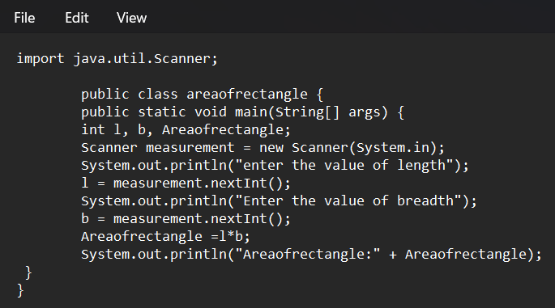

**Output:**

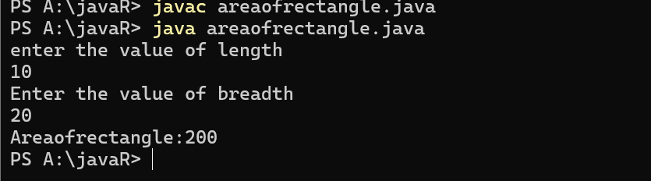

**ERROR TABLE:**

|  |  |
| --- | --- |
| **Code Error** | **Code rectification** |
| 1.While using for iteration, not giving the conditions correctly.  2.Declaring the data type as double instead of int. | 1.We should give iterative statements correctly.  2.We should give the data type as int for integers. |

**PROGRAM-3:**

**Aim:**Write a program in java for area of triangle using heron’s formula.

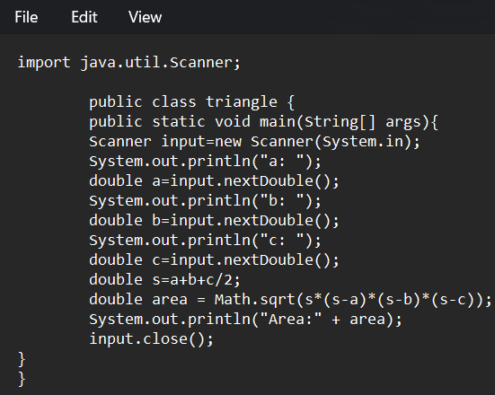

**Output:**

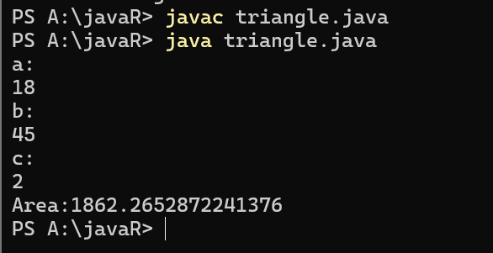

ERROR TABLE:

|  |  |
| --- | --- |
| **Code Error** | Code rectification |
| 1.While printing the variable not giving + sign.  2.Not closing the scanner. | 1.We should give correct indentation.  2.Closing the scanner is must. |

**PROGRAM-4(a):**

**Aim:**Write a program in java for converting temperature from celsius to fahrenite.

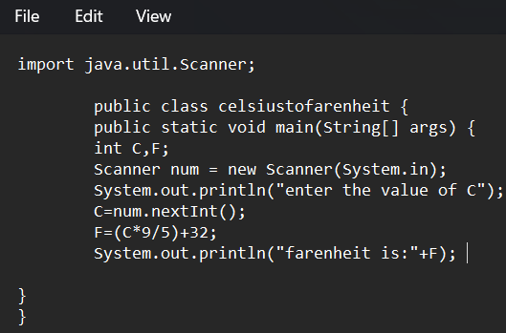

OUTPUT:

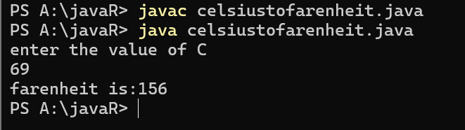

**PROGRAM-4(b):**

**Aim:**Write a program in java for converting temperature from fahrenite to celsius.

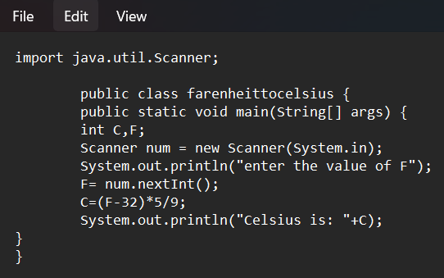

**Output:**

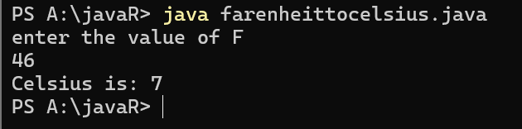

**ERROR TABLE:**

|  |  |
| --- | --- |
| **Code Error** | **Code rectification** |
| 1.While printing the variable not giving + sign.  2.Not closing the scanner. | 1.We should give correct indentation.  2.Closing the scanner is must. |

**PROGRAM-5:**

**Aim:**Write a program in java for factorial of a number.

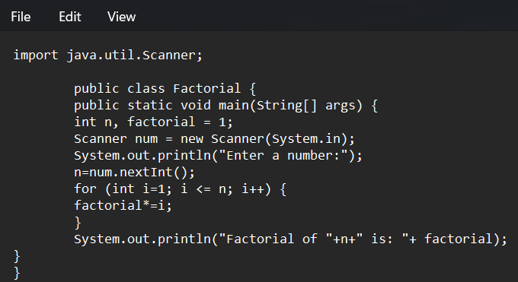

OUTPUT:

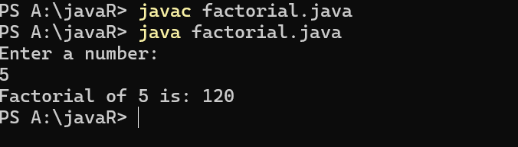

ERROR TABLE:

|  |  |
| --- | --- |
| **Code Error** | **Code rectification** |
| 1.While using for iteration, not giving the conditions correctly.  2.Declaring the data type as double instead of int. | 1.We should give iterative statements correctly.  2.We should give the data type as int for integers. |

**PROGRAM-6:**

**Aim:**Write a program in java for fibonacci series.

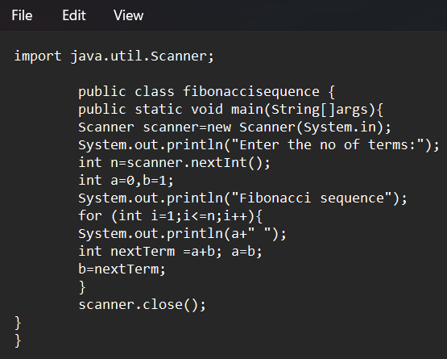

OUTPUT:

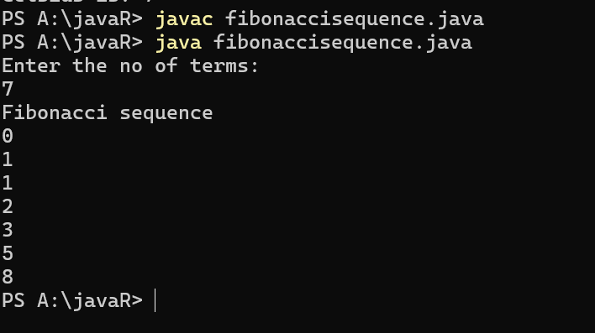

ERROR TABLE:

|  |  |
| --- | --- |
| **Code Error** | **Code rectification** |
| 1.Giving space between next and Double.  2.Not giving parenthesis after closing the input. | 1.Should not give space between next and Double.  2.We must put parenthesis after closing the input. |

**WEEK -3:**

**PROGRAM-1:**

**AIM: To create java program with following instructions :**

**1.Create a class with name Car**

**2.Create four attributes named car_color,car_brand, fuel_type, mileage**

**3.Create these methods named start(),stop(),service()**

**4.Create the objects named car, car1,car2**

**CODE :**

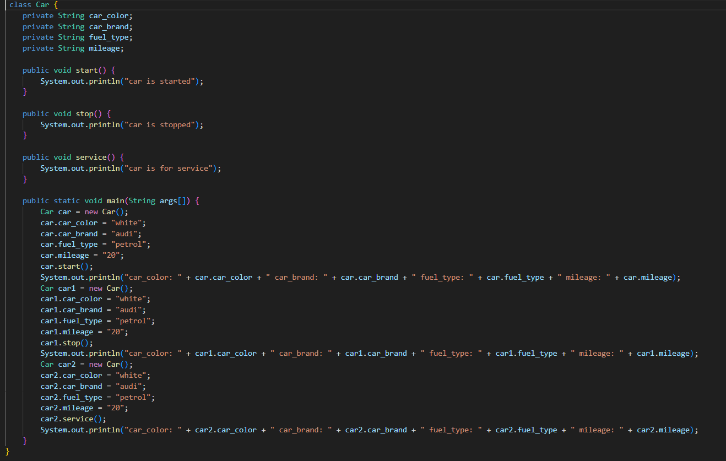

**OUTPUT:**

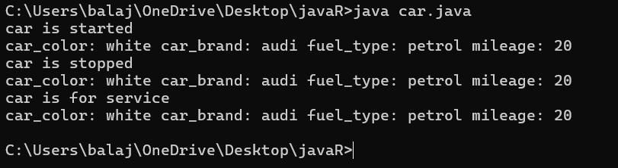

**Error table :**

|  |  |  |  |
| --- | --- | --- | --- |
| **S.no** | **Error name** | **Cause of error** | **Rectification** |
| **1** | **Syntax Error** | **Missing ‘{‘** | **‘{‘ added** |
| **2** | **Compile time Error** | **Mispelled Variable call** | **Rectified with**  **Correct variable name** |
| **3** | **Case sensitive error** | **Uppercase and lowercase** | **rectified** |

**Class diagram:**

|  |
| --- |
| **car**  **---------------------- --- -**  **-car_color:string**  **-car_brand:string -**  **-fuel_type:string**  **-milage:double**  **---------------------- ---**  **+start():void**  **+stop():void**  **+service():void** |

**PROGRAM-2:**

**Aim : To create a class BankAccount with methods deposit() and withdraw() create two subclasses savingsaccount and checkingaccount override the withdraw method in each subclass to impose different withdrawal limits and fees  
  
CODE :**

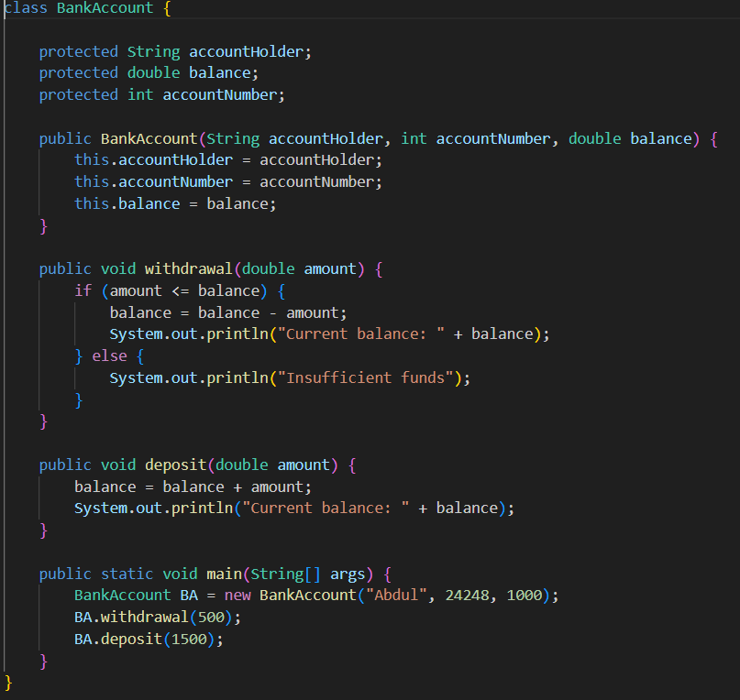

**OUTPUT:**

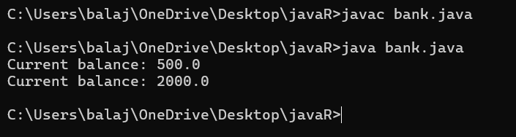

**Error table:**

|  |  |  |  |
| --- | --- | --- | --- |
| **S.no** | **Error name** | **Error name** | **Rectification** |
| **1** | **Name Error** | **Undefined name** | **Correct variable**  **Name replaced** |
| **2** | **Syntax Error** | **Missing Parenthesis** | **Parenthesis Added** |
| **3** | **Logical Error** | **Incorrect Condition** | **Condition Rectified** |

**Class diagram:**

|  |
| --- |
| **BankAccount**  **----------------------------------------------------------**  **-balance: double**  **----------------------------------------------------------**  **+BankAccount(intialBalance: double)**  **+deposit(amount: double):void**  **+withdraw(amount: double):void** |